Binary Code Bracelet or Necklace

Materials:
- Two colours of beads
- String

Follow the binary code to order your beads on your sting into a word.
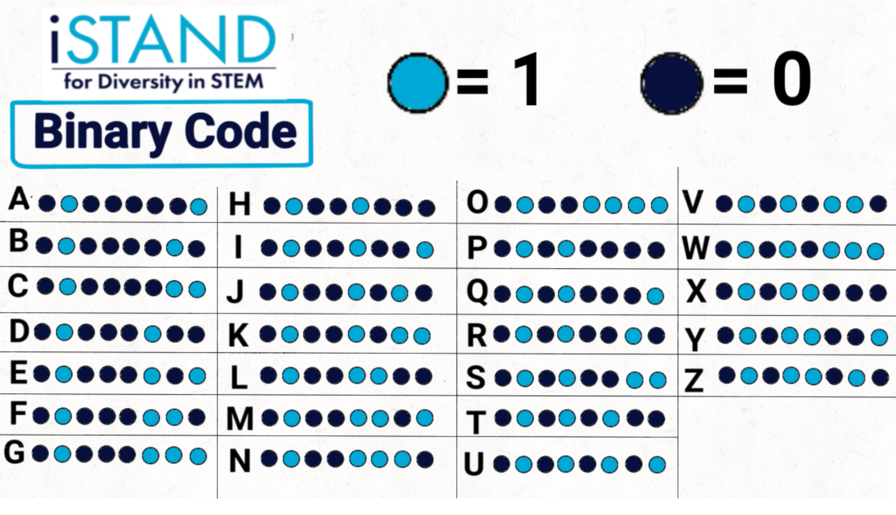

Here’s an example: This would be the “I” code for an iSTAND bracelet.

This would be UBC:

