Pumpkin Patch Sugar Cookie Recipe
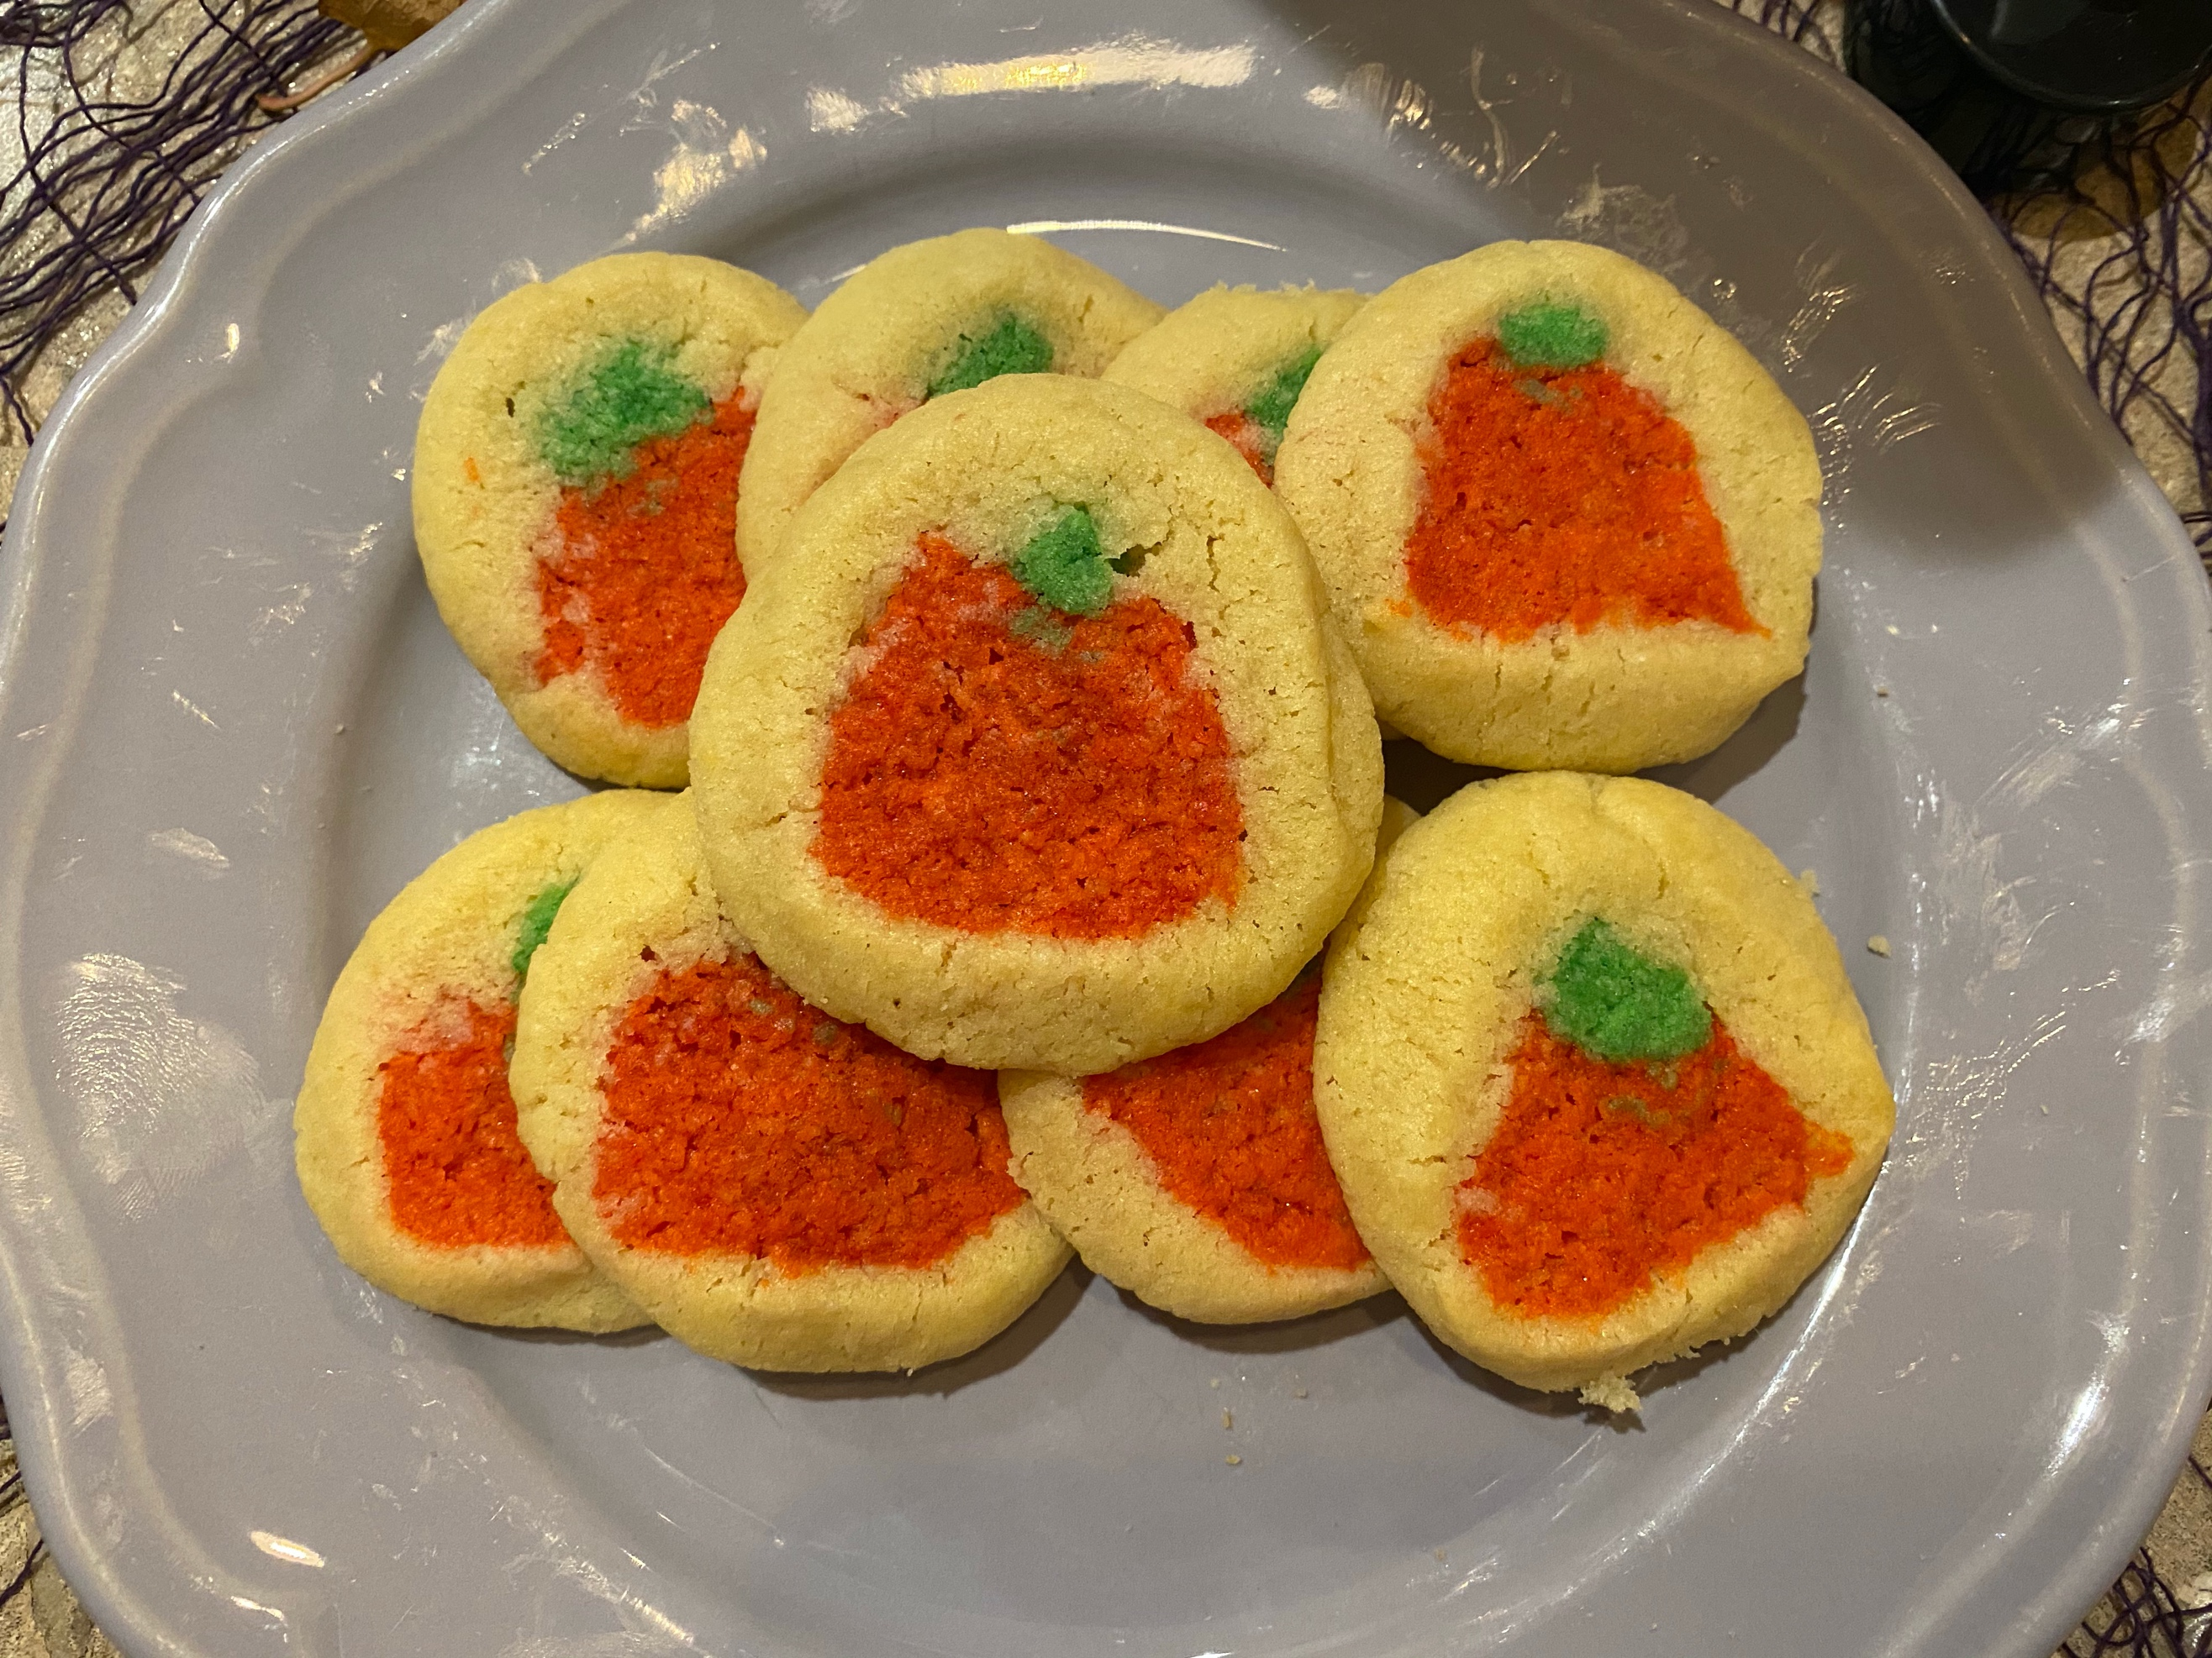

Ingredients
- 4 tablespoons melted butter
- 1 egg yolk
- 1/3 cup granulated sugar
- 1/2 teaspoon vanilla extract
- 1/2 cup and 2 tablespoons all-purpose flour (add more flour if the dough feels too wet)
- 1/4 teaspoon baking soda (what makes our cookies rise!)
- 1/8 teaspoon salt
- Food colouring
Steps
- Preheat the oven to 350 degrees
- Prepare your cookie tray with parchment paper or grease the tray
- Combine all wet ingredients and mix together well:
- Melt butter in the microwave first then add it to your mixer
- Separate your egg and use the yolk only
- Add sugar (sugar is a wet ingredient because it will not fully combine with your other ingredients if you mix it in with the dry ingredients and your cookies will be grainy)
- Add vanilla
- Sprinkle your dry ingredients over top of your wet mixture:
- Add flour
- Add baking soda
- Add salt
- Mix all ingredients together until just combined (don’t over mix)
- Use a spatula to scrap the sides of your bowl and form the dough into a ball
- Split your dough in half
- Use one half of your dough and take a pinch of dough from it
- Add green food colouring to the pinch of dough (for the stem of our pumpkins)
- Add red and yellow flood colouring the one half of dough we took the pinch from (for the pumpkin rind)
- Roll the green and orange dough out separately into long snakes
- Flatten the plain dough out and stack the orange dough and then green dough on top
- Cover the orange and green dough completely with your plain dough and give a little roll to form a round log shape
- Take a knife and cut approximately 1inch slices of your dough (you should see the pumpkin now!)
- Place the cookies on the cookie tray and put them into the oven
- Bake the cookies for approximately 10 minutes
- Let your cookies cool on the cookie tray for about 2minutes then transfer them to a wire rack

