Learn all about the brain by watching the video. You can fill in the blanks and answer the questions as you follow along or do them after.

1.What is squishy like Jell-O, looks like a walnut and is roughly the size of two clenched fists together? ______________
2. The brain weighs only ______ lbs.

3.The brain is part of the ____________ nervous system.

4.The brain is responsible for processing ___________ information and sending electrical signals to create ___________ commands.
5.How does the brain do all these amazing tasks? ______________
Label the Nerve Cell:
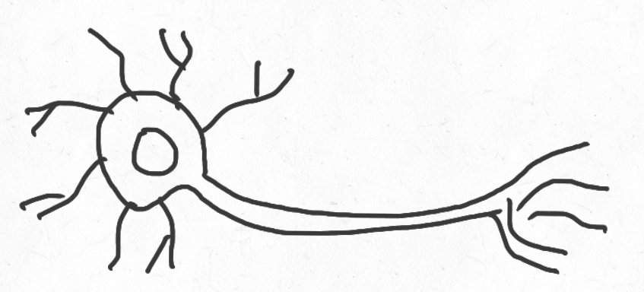

__________________
__________
____________________
Colour the Different Regions of the Brain: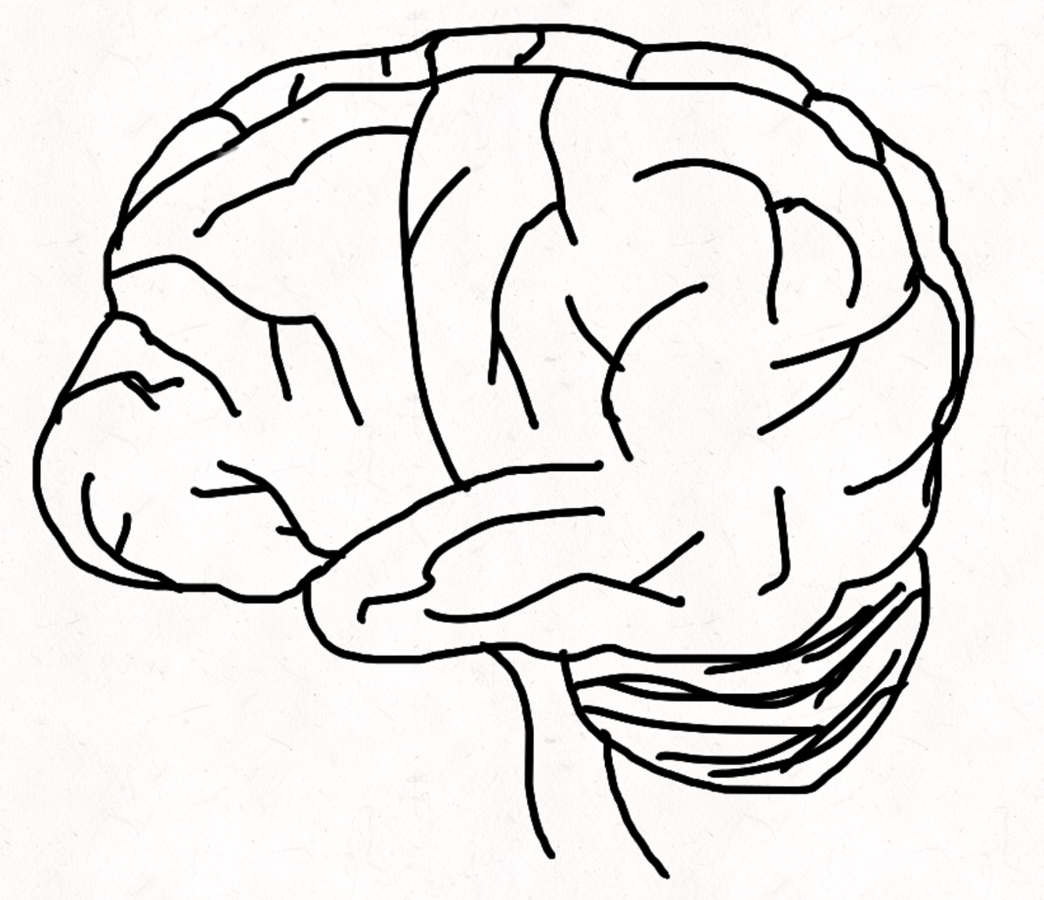
Match the different regions of the brain to the correct description:
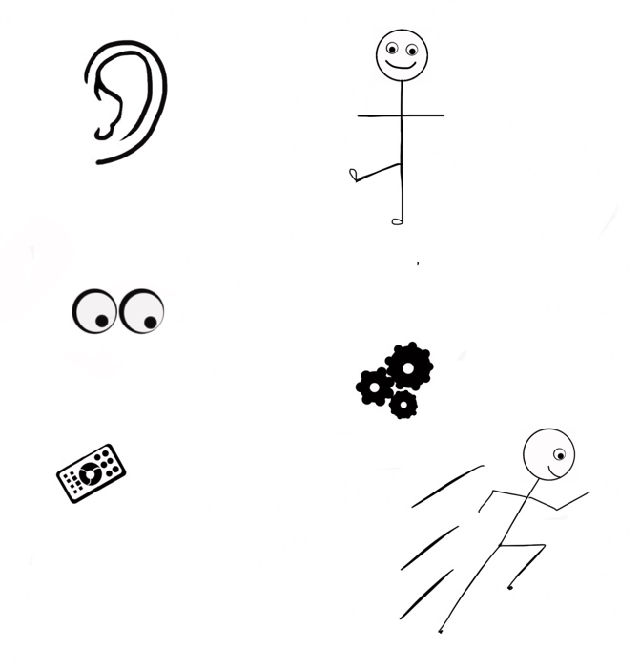
- Frontal Lobe
- Motor Cortex
- Parietal Lobe
- Occipital Lobe
- Temporal Lobe
- Cerebellum
Visual processing and interpretation

Sound processing and interpretation
Sensory Integration Center
Balance and Coordination
Our remote control: emotion, personality, memory, decision making and more!

Movement
Label the Brain:

