Please find below a list of helpful resources for STEM activities. Currently, iSTAND is also developing short activity videos, which will also be housed on our Youtube Channel (link below). While we do encourage you to explore the resources, iSTAND is not responsible for the content of external websites. If you would like to provide feedback or have suggestions for further resources, please contact us at istand.stem@ubc.ca.

Grades 1-3
https://www.khanacademy.org/
Lesson plans, videos, interactive learning with many subjects

https://kidshealth.org/en/kids/center/htbw-main-page.html?WT.ac=k-nav-htbw-main-page
Explore how the human body works through quizzes and games

https://www.scienceworld.ca/
Fun activities you can do at home

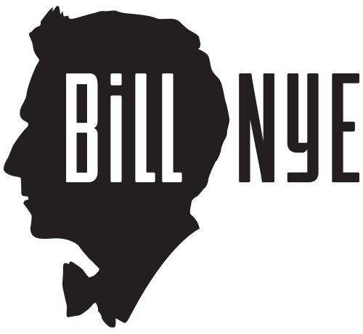
https://billnye.com/home-demos
Fun activities you can do at home
https://ocean.org/learnonline/#crafts
Ocean Colouring Sheets with Fun Facts and other crafts

https://www.pbslearningmedia.org/student/
Watch videos about health, art, science and math

https://spaceplace.nasa.gov
Learn about space with games, crafts and activities

Grades 4-7
https://www.khanacademy.org/
Lesson plans, videos, interactive learning with many subjects

https://kidshealth.org/en/kids/center/htbw-main-page.html?WT.ac=k-nav-htbw-main-page
Explore how the human body works through quizzes and games

https://www.scienceworld.ca/
Fun activities you can do at home

https://billnye.com/home-demos
Fun activities you can do at home

https://www.vanaqua.org/education/aquafacts
Learn facts about animals

https://www.pbslearningmedia.org/student/
Watch videos about health, art, science and math

https://spaceplace.nasa.gov
Learn about space with games, crafts and activities

https://kids.frontiersin.org/
science for kids edited by kids

Grades 8-12
https://www.khanacademy.org/
Lesson plans, videos, interactive learning with many subjects

https://www.nlm.nih.gov/research/visible/getting_data.html
The Visible Human Project: explore the human body through MRI and CT images of male and female cadavers

https://kidshealth.org/en/teens/?WT.ac=t2t
Learn about your health and body

https://www.pbslearningmedia.org/student/
Watch videos about health, art, science and math

https://kids.frontiersin.org/
Science for kids edited by kids

Additional
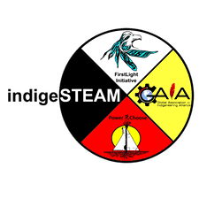
https://indigesteam.ca/
Resource for Indigenous STEM Camps

https://www.youtube.com/channel/UC7cR79KQ957nZHlGvBXyGcA/featured?view_as=subscriber
STEM activity videos for all

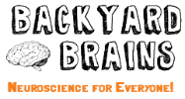
https://blog.backyardbrains.com/2020/04/educational-and-physical-activities-for-stay-at-home-students-get-those-brain-gains/
STEM Activities and recommendations for other resources

