Mathapults Part B: Check Your Knowledge
- Name the angles:
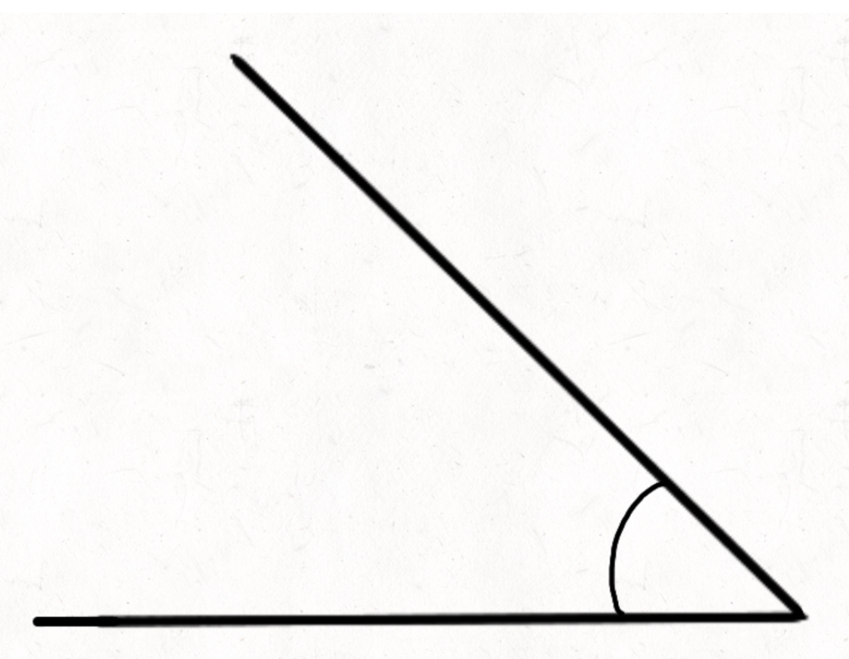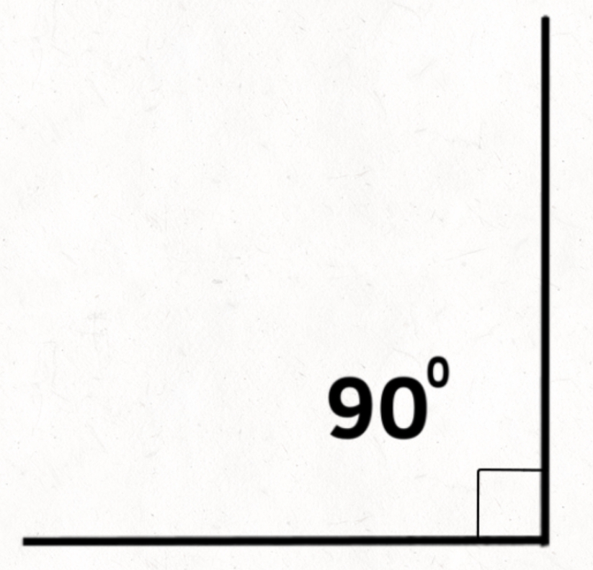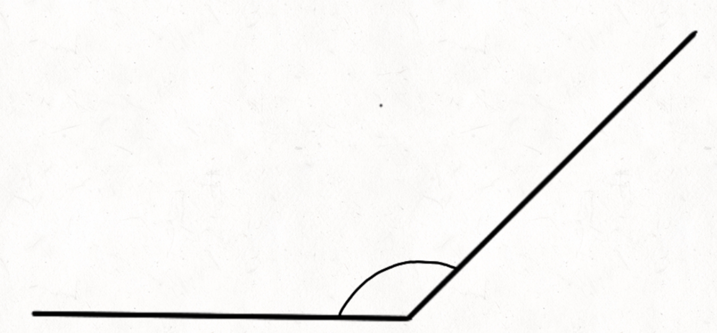

_______________ _______________ _______________

Obtuse Angle
Right Angle
Acute Angle
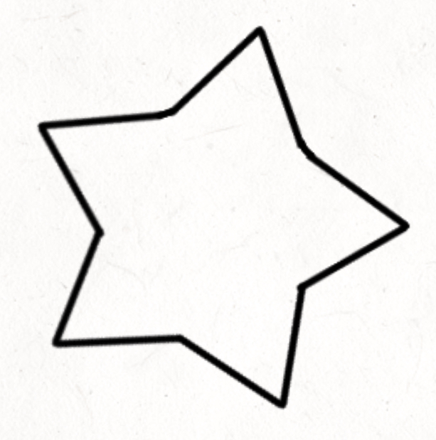
- Circle all the acute angles:

- Circle all the right angles:

- Circle all the obtuse angles:
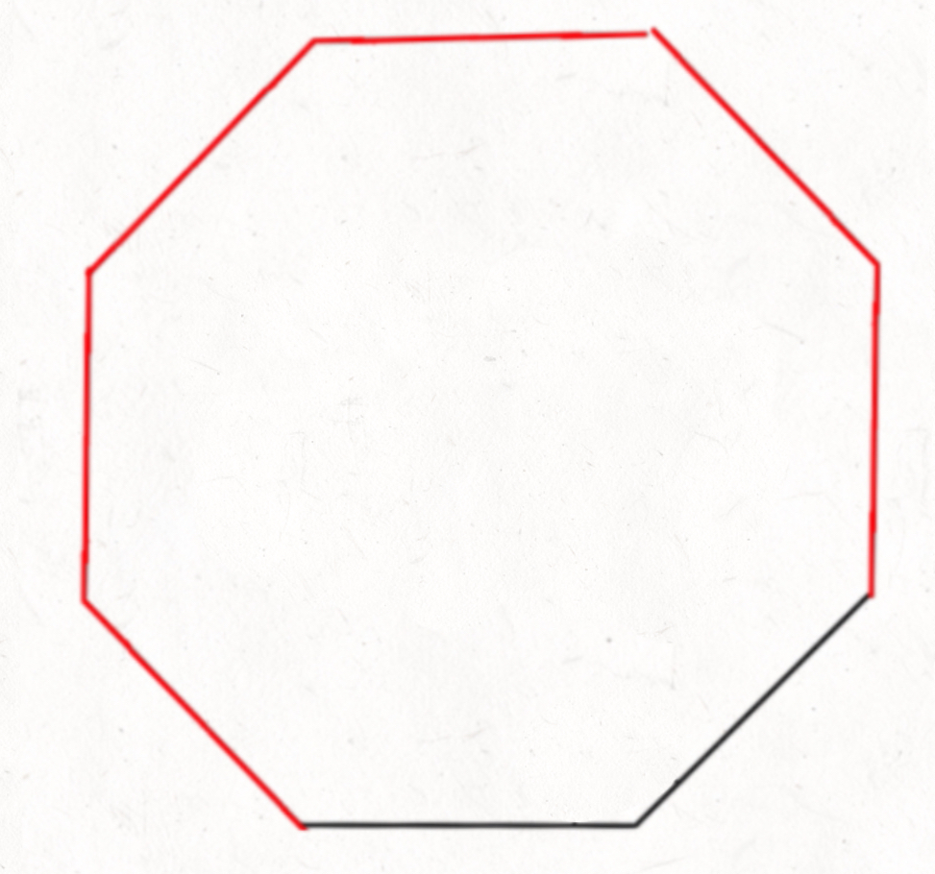

- Draw the greater than or less than symbol (alligator mouth) inside the box. E.g. 10 > 2
<
>
90°

Obtuse Angle
90°

45°

4 < 6
102 > 58
<
<
Obtuse Angle
Acute Angle
180°
180°
130°

180°
- Name which objects are concave, convex or both.
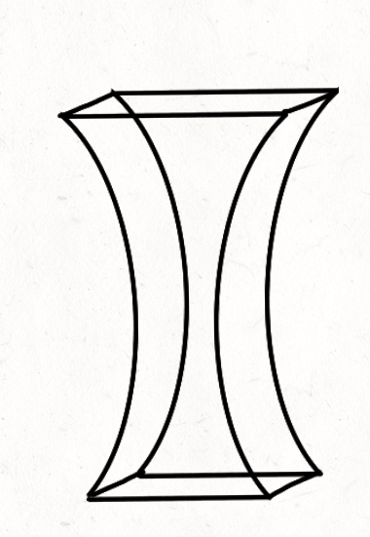
Prism
Spoon
Ball
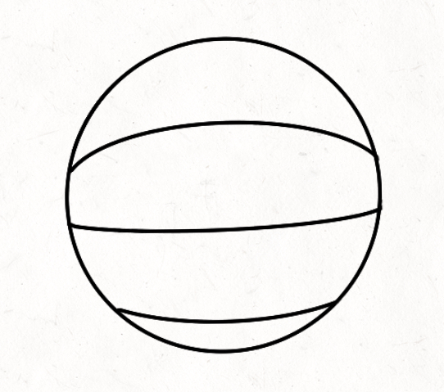
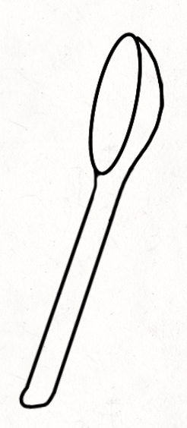

Concave
Convex
Both

Crossword

A | I | R |  | R | E | S | I | S | T | A | N | C | E
 |  |  |  |  |  |  |  |  |  |  |  | O
 |  |  |  |  |  |  | P |  |  |  |  | N
 |  |  |  |  |  |  | R |  |  |  |  | V
 |  | M |  |  |  | C | O | N | C | A | V | E
 |  | E |  |  |  |  | J |  |  |  |  | X |  |  | B
 |  | D |  |  |  |  | E |  |  |  |  |  |  |  | A
 | D | I | S | T | A | N | C | E |  |  |  |  |  |  | S
 |  | A  N |  |  |  |  | T |  |  |  | A | N | G | L | E
 |  |  |  |  |  |  | I |  |  |  | R
 |  |  |  |  | F | U | L | C | R | U | M
 |  |  |  |  |  |  | E

Down
- Equals the middle number
- The object that is launched into the air
- Supports the load
- Curves outward
- Stabilizes the structure
Across
- Slows objects down in the air
- Curves inward
- How far something has traveled
- The space between two intersecting lines
- What the arm turns on (the pivoting point)

