\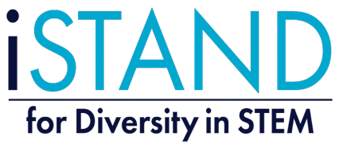
Mathapults Part B: Check Your Knowledge
- Name the angles:
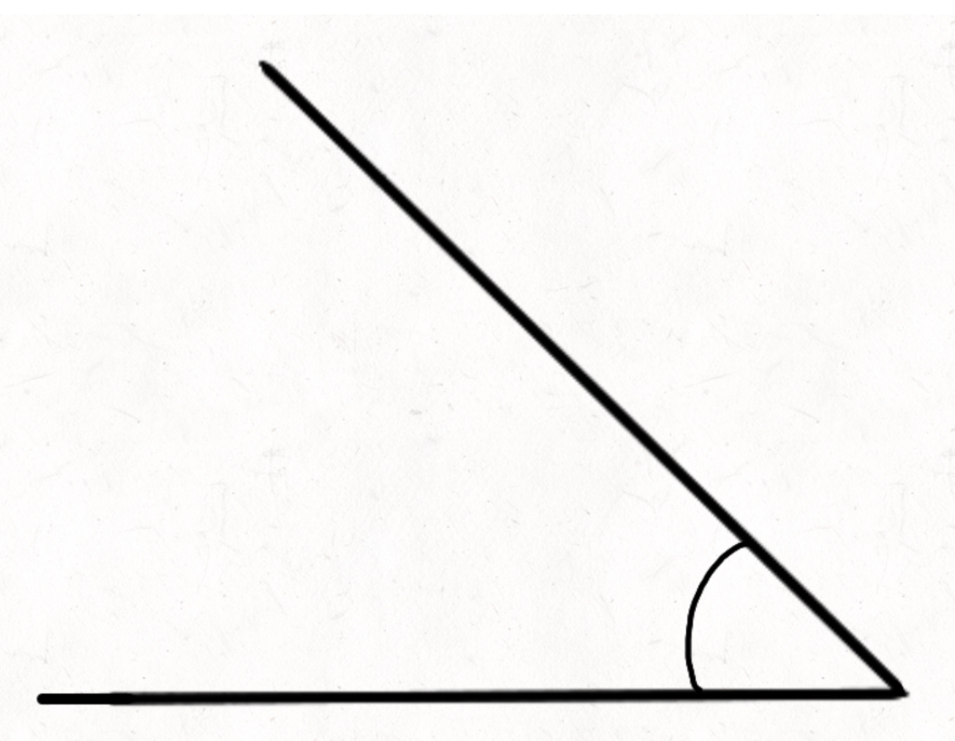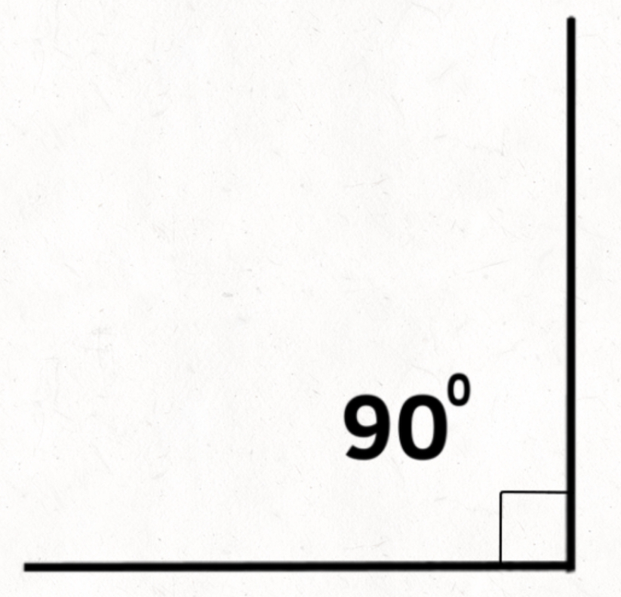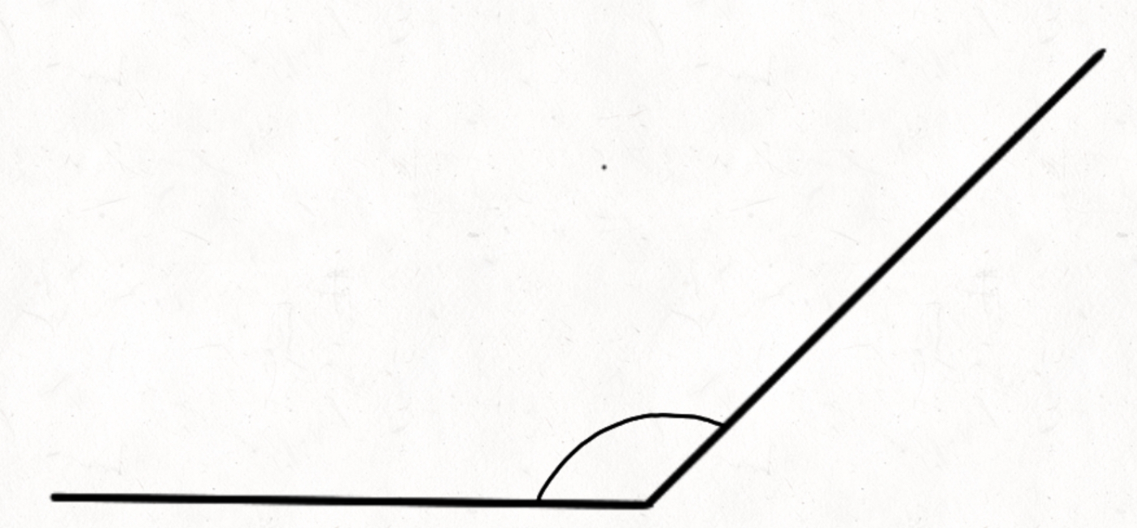

_______________ _______________ _______________

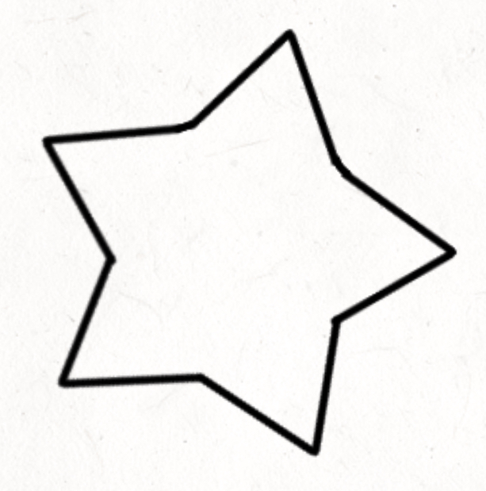
- Circle all the acute angles:

- Circle all the right angles:

- Circle all the obtuse angles:
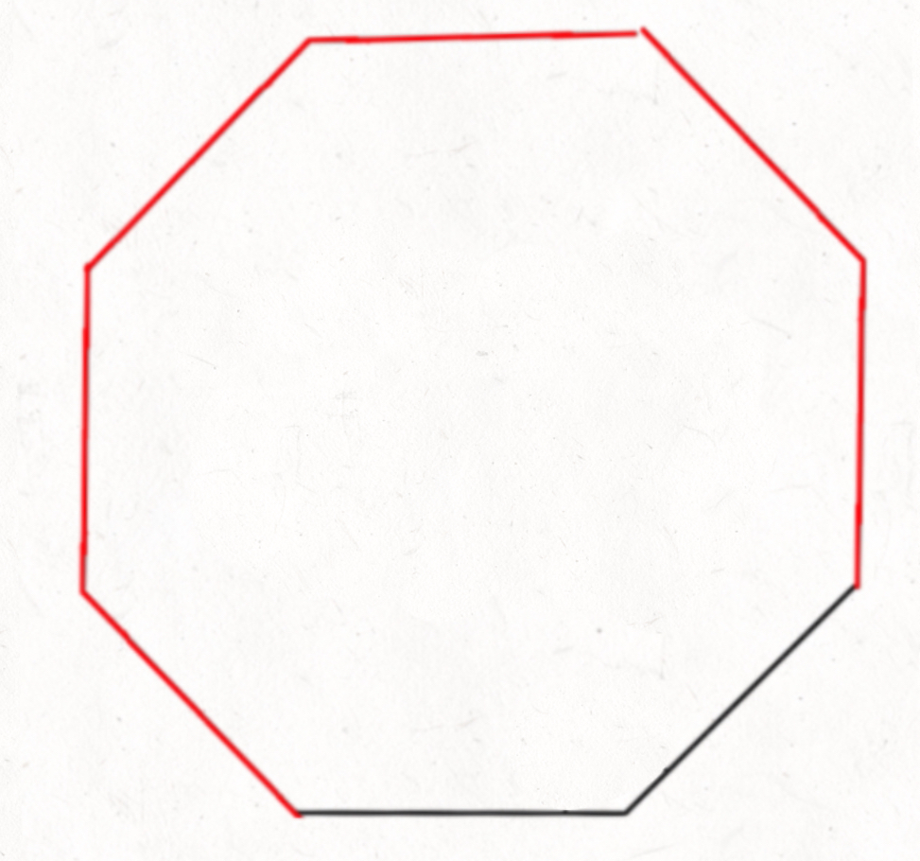

- Draw the greater than or less than symbol (alligator mouth) inside the box. E.g. 10 > 2
90°

Obtuse Angle
90°

45°

4 6
102 58
Obtuse Angle
Acute Angle
180°
180°
130°

180°
- Name which objects are concave, convex or both.
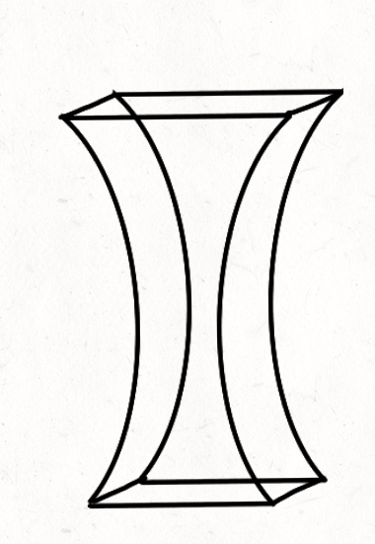
Prism
Spoon
Ball
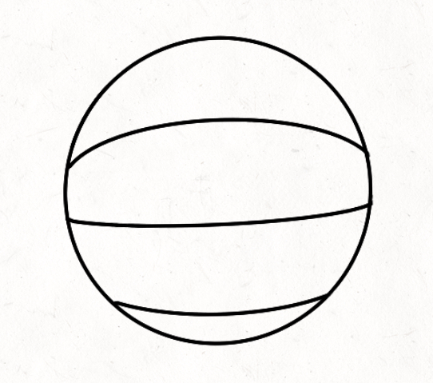
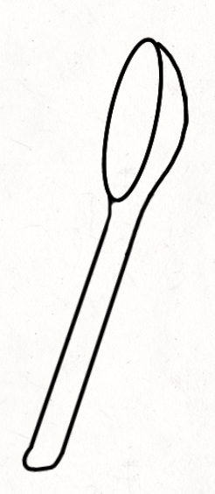

Crossword (Hint: use the important words box on your Mathapult Part B worksheet)

1. |  |  |  |  |  |  |  |  |  |  |  | 8.
 |  |  |  |  |  |  | 7.
 |  | 6. |  |  |  | 2.
 |  |  |  |  |  |  |  |  |  |  |  |  |  |  | 9.
 | 3.
 |  |  |  |  |  |  |  |  |  |  | 5.
 |  |  |  |  | 4.

Across
- Slows objects down in the air
- Curves inward
- How far something has traveled
- What the arm turns on (the pivoting point)
- The space between two intersecting lines

Down
5. Supports the load
6. Equals the middle number
- An object that is launched into the air
- Curves outward
- Stabilizes the structure

